Advanced Database System
SQL final report
Gym database management system

Mohamed223331@bue.edu.eg | 223331 | Mohamed wafiq
Maximos226650@bue.edu.eg | 226650 | Maximos Ashraf
Mohamed226791@bue.edu.eg | 226791 | Mohamed abdelnasser

Linked servers:
two SQL Server instances (SQLEXPRESS and SQLEXPRESS2) with their respective components
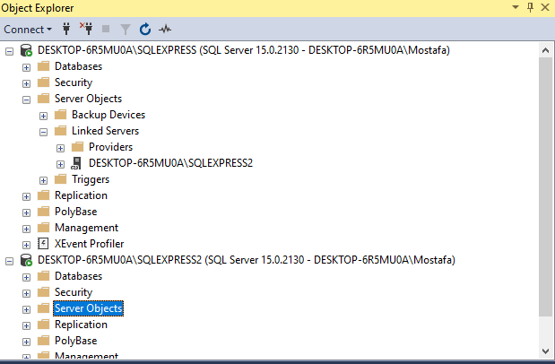

Integrations: Complete integration between the two servers, SQLEXPRESS and SQLEXPRESS2, involves establishing a seamless connection to share and manage data from database Gym to database Gym2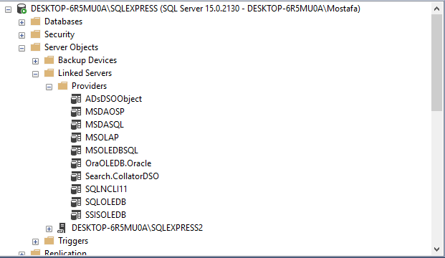
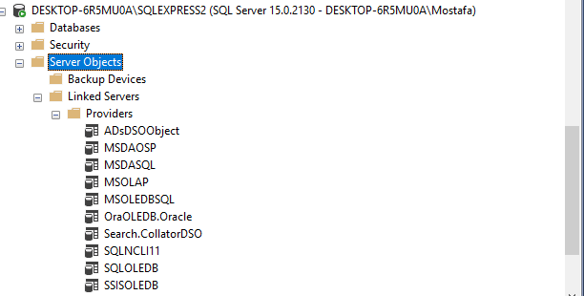

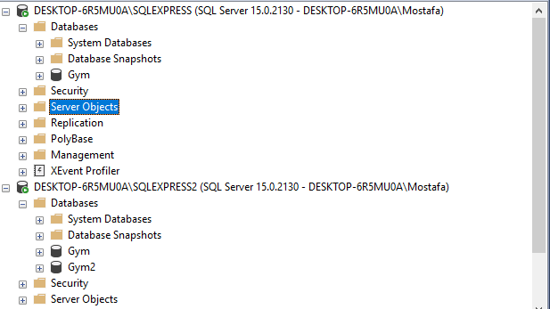
The same tables at database Gym in sqlexpress1 now at sqlexpress2 at database Gym2

The registered servers::
The Registered Servers window organizes multiple server instances under the Gym all branches
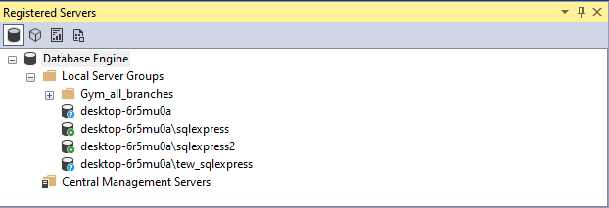

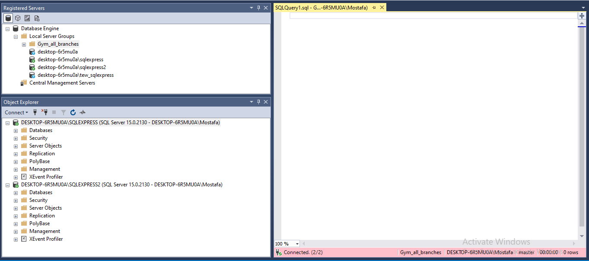

Fragmentations:
1)vertical_fragmentations:
1)The SQL query demonstrates vertical fragmentation by selecting specific columns (Ssn, Fname, Initial, Lname, Address) from the Employee table and creating a new table VerticalFragmentEmpPersonalInfoTABLE. (Maximos 226650)
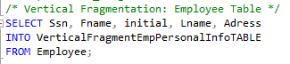

2) The SQL query demonstrates vertical fragmentation that the Employee and G_branch tables are being joined, then Ssn, Branch_num, Super_ssn, and Salary columns are selected to create a new table named VerticalFragmentEmpBranchInfoTABLE(fragment). (mohamed wafiq 223331)
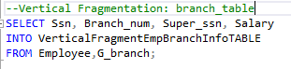
3) This query will result in a new table, VerticalFragmentOtherInfo, having only the chosen columns(Equip_code, Equip_name, and Equip_price) from the main table(equipment). Fragmentation like this will be useful for boosting the performance when queries require repeatedly a subset of columns from the entire table by reducing the number of data in processing and storage. (mohamed226791)
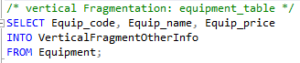
Testing vertical fragmentations:
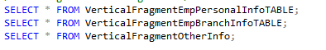
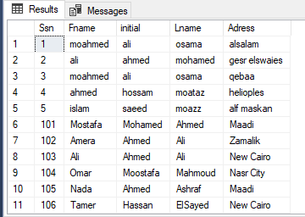
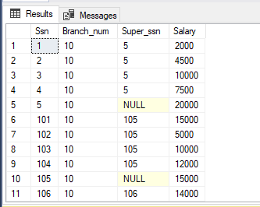
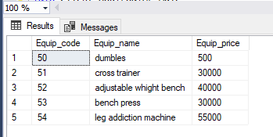

2)horizontal fragmentations:
1) The SQL query demonstrates horizontal fragmentation by selecting rows from the Client table where Gender is 'Male' and storing them in a new table named Client_HORIZONTAL_Male. (Maximos 226650)
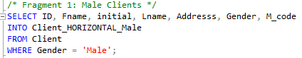
2) This query illustrates horizontal fragmentation applied to the Client table, where the data is divided based on a certain condition-in this case, gender. Horizontal fragmentation splits the rows of a table into different fragments based on a predicate, which helps optimize query performance by focusing on smaller, more relevant subsets of data. (mohamed 226791)
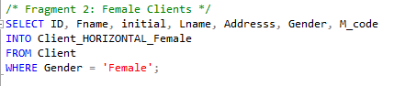
3) This SQL query generates an horizontal fragmentation that extracts information about morning training activities from the "Activity" table. It selects the columns TSsn, CID, and Train_time and inserts the results into a new table named Activity_HORIZONTAL_Morning (fragment). The query filters rows where the Train_time column contains values ending with "AM", indicating morning times. (mohamed wafiq 223331)
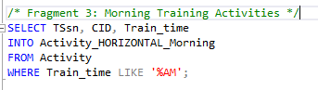
4) The query performs horizontal fragmentation of the Activity table to extract records related to afternoon or evening training activities. (group_work)
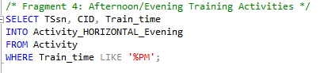
Testing the fragments:
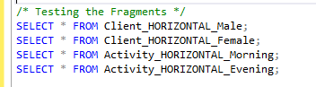
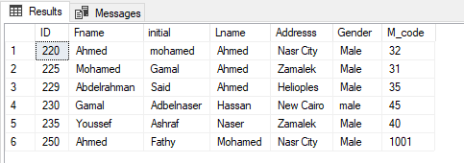
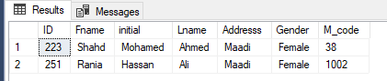
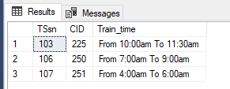
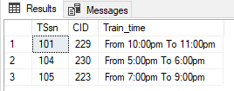
Hybrid_fragmntations:
Firstly: vertical fragmentation (done by the whole group):
Vertical Fragmentation 1: Basic Supplement Details
This fragmentation shows the vertical fragmentation on the supplement table, in which the data is divided along columns. In a vertical fragment of a table, there is a split into fragments based on column selection; this enhances performance since one deals with smaller chunks of data that are relevant. The result of this would be a new table called Supplement Basic, which consists of the basic details of supplements.
Vertical Fragmentation 2: Pricing and Description
This query also demonstrates the vertical fragmentation on the supplement table by focusing on another set of columns. By dividing the table based on column selection, vertical fragmentation will help improve data processing and storage. The output is a new table called Supplement Details, which includes all the information about the supplements.

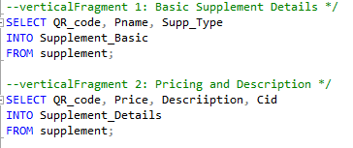
Secondly: horizontal on vertical fragment ( berforming_hyprid)
1) This query shows a hybrid fragmentation that embeds both vertical and horizontal fragmentations. First, it vertically fragments the supplement table to create the Supplement Basic table with columns and then horizontally fragments the created vertical fragment based on the condition. Hybrid fragmentation means it optimizes data storage and queries by splitting data both by columns (vertical) and rows (horizontal) on specific criteria. The result is a new table, Supplement_Basic_food, comprising the basic information about food-type vitamin supplements. (mohamed226791)
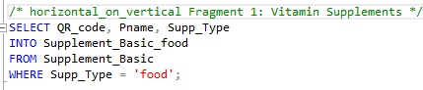
2) The given SQL query demonstrates hybrid fragmentation, a combination of horizontal and vertical fragmentation techniques. It first vertically fragments the supplement table by selecting three main features (QR-code,Pname,supp_type) after that it horizontally fragments the supplement_basic fragment by select (QR-code,Pname,supp_type) from it and applying a where condition supp_type = ‘Care’, This hybrid approach creates a new table, Supplement_Basic_care.(mohamed wafiq 223331)
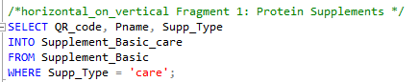
3) The SQL query demonstrates a Hybrid fragmentation by selecting specific columns (QR_code, Price, Description, Cid) from the Supplement_Details table and isolating rows where Price < 100. The results are stored in a new table Supplement_Details_Affordable (Maximos 226650)
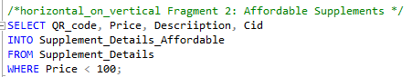

4) The query isolates rows from Supplement_Details with Price >= 100 and specific columns (QR_code, Price, Description, Cid) into a new table Supplement_Details_Expensive. (group_work)
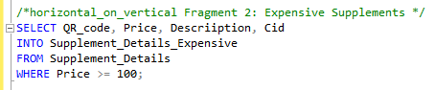
Testing the hybrid fragmentations:
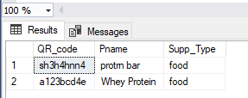
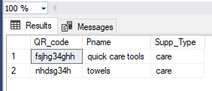
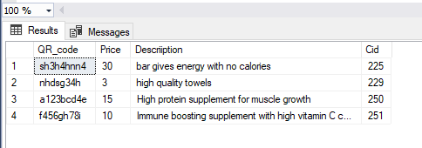
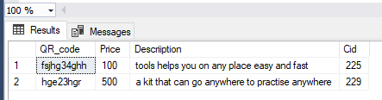

Querys on the register server:
1) The SQL query joins the Report and Client tables based on the Client_ID column,then filters the results to include only male clients with a progress level of 'A', and then selects and concatenates the fname and lname columns as full name. it finally displays the fullname, Gender, and Progress_level for each matching record (mohamed 223331)
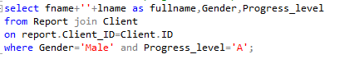
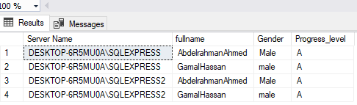
2) This query performs a RIGHT OUTER JOIN between the Client and Membership tables to retrieve information about female clients who are associated with a membership. A RIGHT OUTER JOIN ensures that all records from the Membership table are included, even if there is no matching record in the Client table. In case of no client for some membership, the result shall contain the membership details as well, with NULL values for Client columns. The query will result on a list of all the female clients who have memberships along with their ID, Fname, and Lname from both servers. For the memberships with no female clients, the memberships will be included in the result but with NULL values for the client's information. (226791)
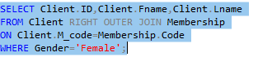
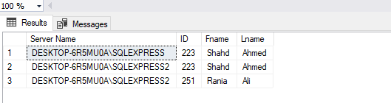

3) The query retrieves the number of cleaners grouped by salary, filtering only those with salaries greater than 4000. It joins the Employee and Cleaner tables based on their Ssn fields and uses GROUP BY to summarize and count cleaners for each salary. (Maximos 226650)

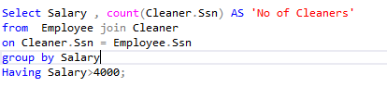
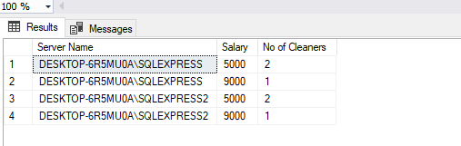
4) This SQL query joins the Employee and Cleaner tables based on the Ssn column. then it selects the Fname and Lname from Employee , concatenates them together into ‘Full name’, and also includes the Cleaner.Ssn column. The results are ordered by the concatenated Full name in ascending order (mohamed 223331)
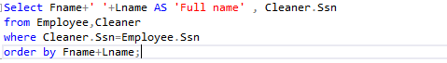
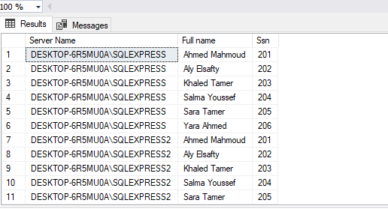

5) This query joins the repairman and Maintenance tables to fetch details about maintenance activities performed by repairmen for a given repair time as 12:00:00. Also, it includes a subquery where it filters the repairmen according to the records of maintenance that occurred at a given time. It lists down the respective repairmen who did maintenance at exactly 12:00:00 and their respective maintenance equipment codes from both servers. This helps in the identification of which repairmen were assigned to which equipment during the specified repair time. (mohamed226791)
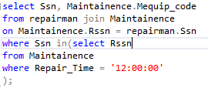
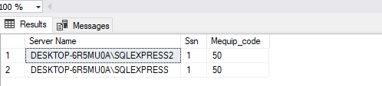
6) The query counts the number of products in the supplement table with a price greater than $30 and displays the result as number of products with price more than 30$. The output shows the count grouped by server name, with each having 2 products (Maximos 226650)
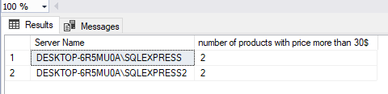

Transactions:
- insertion transaction: The script uses a transaction with error handling. It attempts to insert a record into the Employee table, commits on success, or rolls back and displays an error message if the insertion fails, ensuring data integrity. (Maximos 226650)
Success_scenario
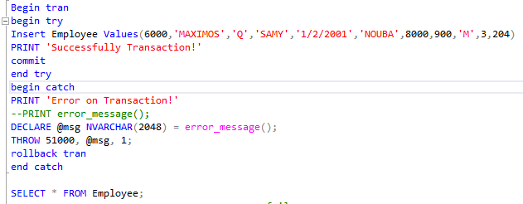
Fail_scenario:
A fail scenario occurs if the INSERT statement violates constraints (e.g., duplicate primary key, data type mismatch, or invalid data). The CATCH block handles it by rolling back the transaction and displaying an error message.
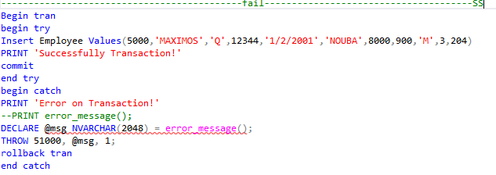
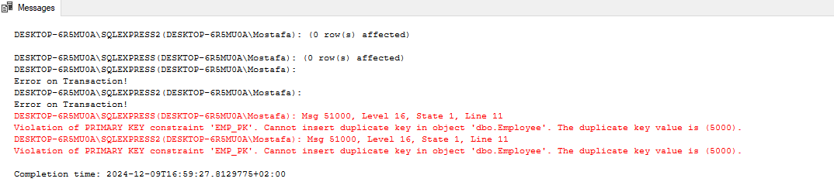

2) update transaction(mohamed226791):
Success scenario:
This would trigger a transaction to update the Salary of an employee (with Ssn = 201) by adding 500 to the present salary. The transaction will commit successfully and the salary will be updated.
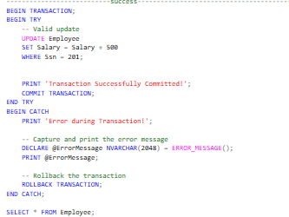
Fail scenario:
Consider a transaction started to update the Salary of employee Ssn = 201 by adding a string instead of a numeric value. Here, due to the wrong data type used in updating, a transaction will result in failure. Thus, none of these changes are applied to the Employee table.
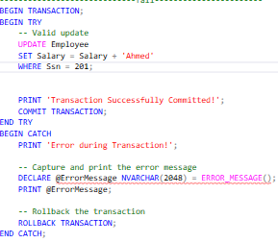
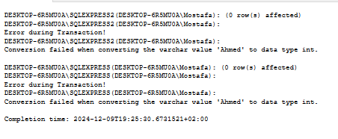
3) This transaction is designed to delete a specific employee from the supplement table based on their QR_code. The transaction ensures data integrity by either committing all changes or rolling them back if an error occurs. The DELETE statement targets the employee with the specified QR_code. The TRY...CATCH block provides error handling and recovery mechanisms. The COMMIT statement makes the changes permanent, while the ROLLBACK statement undoes the changes if an error occurs. The final SELECT statement verifies the state of the supplement table after the transaction (mohamed 223331)
Success scenario: in success scenario I entered right input in QR_code to complete the transaction successfully it will delete a specific employee based on supplement QR_code (mohamed 223331)
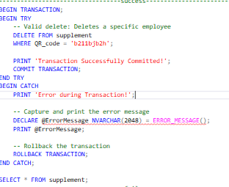
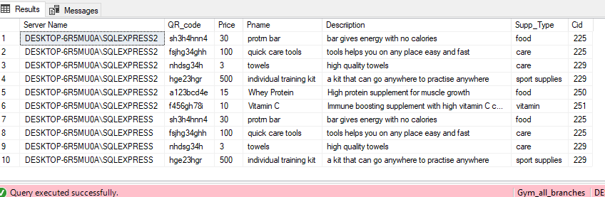
Fail scenario: for fail scenario I entered wrong input “another data type ” which led to a fail in transaction (mohamed 223331)
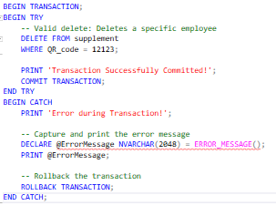
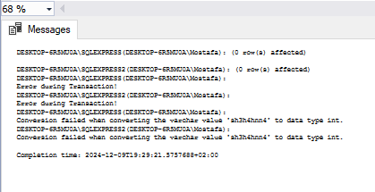

Set_operators:
1) This query will fetch female employees' records, whose Gender = 'F', from the Employee table in the Gym database on the DESKTOP-6R5MU0A\\SQLEXPRESS server and perform an EXCEPT operation to exclude records that match a condition from the Employee table in the Gym2 database on the DESKTOP-6R5MU0A\\SQLEXPRESS2 server. Results will include a list of female employees from the Gym database whose work hours are less than or equal to 6, excluding all those employees who, with more than 6 work hours, pop up in the second Employee table- Gym2. (mohamed226791)
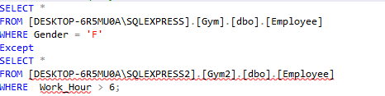
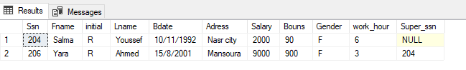
2) This query utilizes the UNION ALL set operator to combine results from two different servers, the first query retrieves employee information from the Gym2 database where the Salary > 3000, while the second query from the other server retrieve same data of the first query with bonus > 1000 then UNION ALL operator used to merges these two result sets, including potential duplicates, to provide a comprehensive view of employees meeting either of the specified criteria. (mohamed 223331)
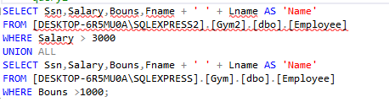
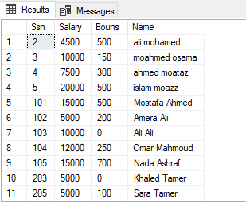
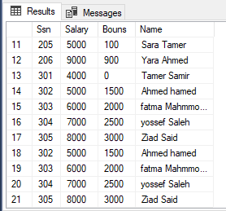
3) This query fetches records from two different Employee tables, one from the Gym database on the DESKTOP-6R5MU0A\\SQLEXPRESS server and another from the Gym2 database on the DESKTOP-6R5MU0A\\SQLEXPRESS2 server, and uses the INTERSECT operator to find common records between them based on certain conditions. The result will be the employees who have a salary above 2000 and also stay in 'Nasr City', which means it satisfies both conditions. Only records present in both the Gym and Gym2 databases, satisfying both conditions, will be returned. (mohamed226791)
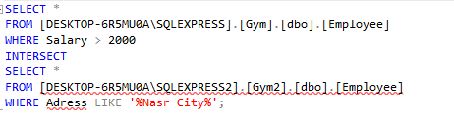
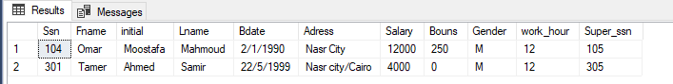
4) The query combines data from two databases using UNION. It retrieves records with a Price > 2000 from one table and those with a Feature containing "Gym & Fitness" from another, merging the results without duplicates. (Maximos 226650)
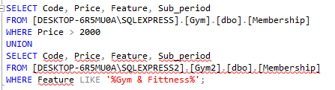
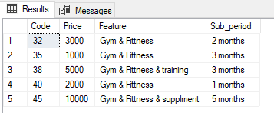
5) This SQL query uses the EXCEPT set operator to combine results from two SELECT statements. Here the first query retrieves male clients from the Gym2 database, while the second query retrieves the same as the first query but with addresses end with 'Z'. The use of EXCEPT operator here is to remove any clients from the first result set that are also present in the second result set, “giving list of male clients from the Gym2 database who don't have addresses ending with ‘Z’ ”. (moahmed 223331)
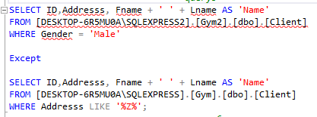
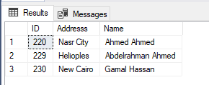

6) The query uses an INTERSECT operation to find common records between two databases. It selects memberships with a Sub period = '3 months' from one database and those with Price < 5000 from another. (Maximos 226650)
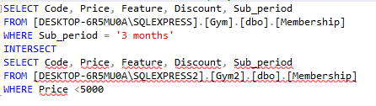
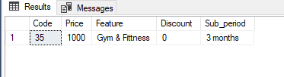

The join quires:
1) This query will bring the male clients from the Client table in the Gym database at DESKTOP-6R5MU0A\SQLEXPRESS with the progress report from the Report table in the Gym2 database at DESKTOP-6R5MU0A\SQLEXPRESS2. The query performs a FULL OUTER JOIN of the two tables on the client ID and then filters to show only male clients with a progress level of 'A'. The query will return a list of male clients (first and last names) who have a progress level of 'A' in their respective report. Resultant set will include full name, and gender of the client along with the progress level from Client and Report table respectively. If a client is in one table but not the other, due to the FULL OUTER JOIN, the information will come out as NULL.(mohamed226791)
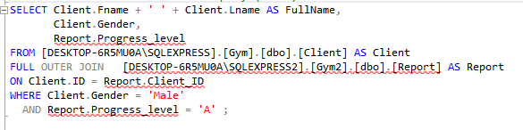
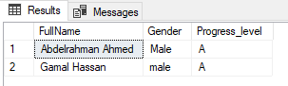
- The query performs a FULL OUTER JOIN between the Cleaner table and the Room table on the Ssn column. It retrieves all records from both tables, matching on Cleaner.Ssn and Room.Cleaner_ssn, and fills unmatched rows with NULL. (Maximos 226650)
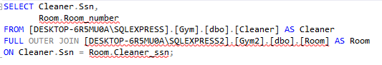
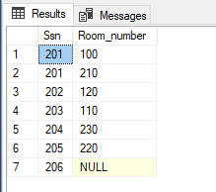

- The query performs an INNER JOIN between the Employee and Cleaner tables based on Ssn. It groups by Employee.Salary and counts the number of cleaners for each salary where Employee.Salary > 4000.(Maximos 226650)
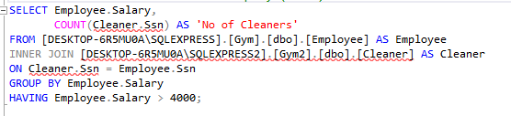
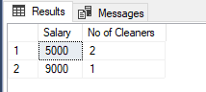
- This SQL query joins two tables, Client and Supplement, to retrieve information about clients and their associated products. It uses an inner join to match rows based on the Client.ID and Supplement.CID. The query selects the Client.ID as ClientID, concatenates the Client.Fname and Client.Lname as Name, and selects the Supplement.Pname as Product Name. This provides a combined view of client and product information. (mohamed 223331)
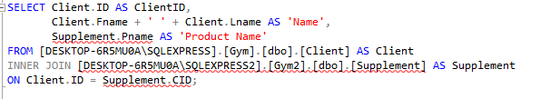
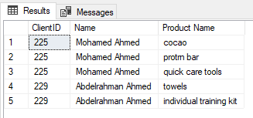

- This SQL query joins the Client and Supplement tables to identify clients who have more than one supplement. It first joins the tables based on the Client.ID and Supplement.CID by using inner join. Then, it groups the results by Client.ID and counts the number of supplements for each client. The HAVING clause filters the results to include only clients with more than one supplement. Finally, the ORDER BY clause sorts the results by the number of supplements in descending order. (Mohamed 223331)
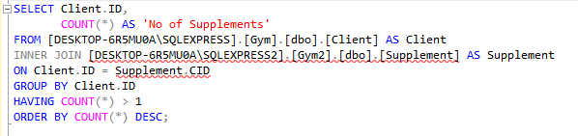
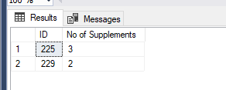
6) This query will fetch a distinct list of employee names (Fname), their respective department names (Dept_name), and branch names (Branch_name) from three related tables: Employee, Department, and G_branch. This uses INNER JOINs to join these tables and filters the results for those employees working in the 'elwadi' branch.
This will return a list of distinct employees - Fname, their respective department names - Dept_name, and the branch name - Branch_name for those employees who work at the 'elwadi' branch.
The DISTINCT keyword ensures that only unique employee names, department names, and branch names appear in the query result, eliminating any duplicates. (mohamed226791)
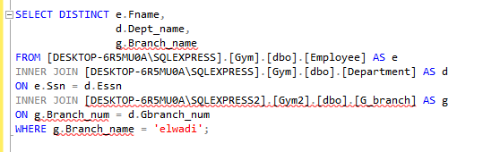
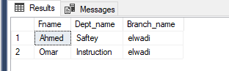
Replication::
1)Distributor configuration
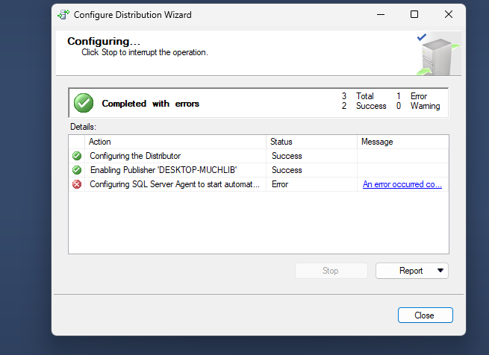

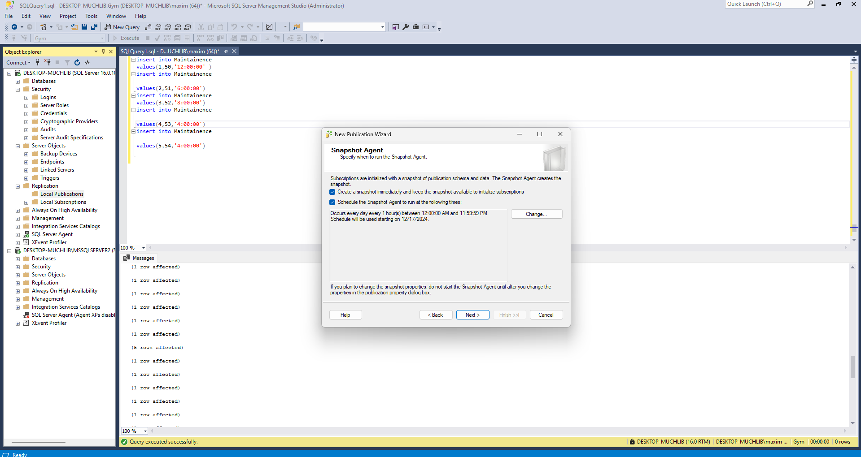
2)publisher configuration
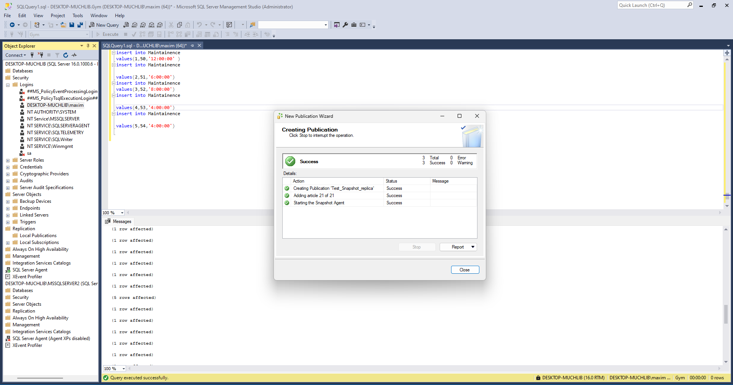

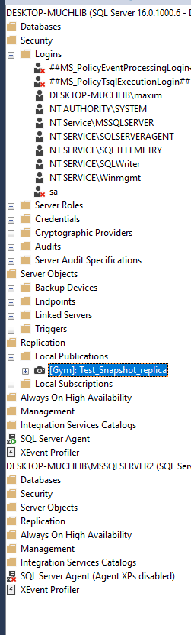
3)subscription configuration
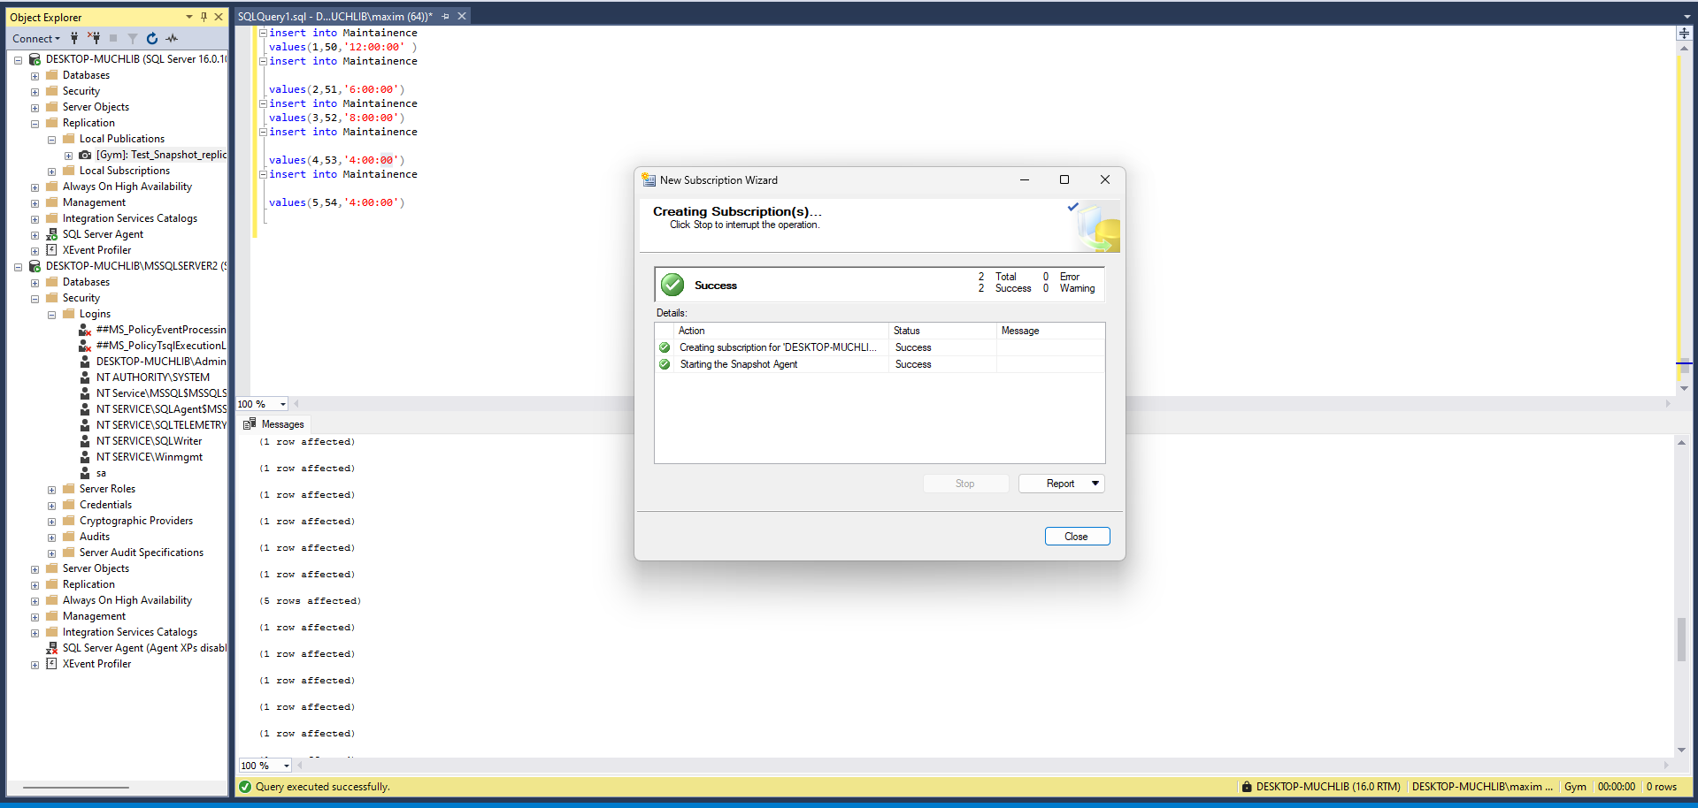
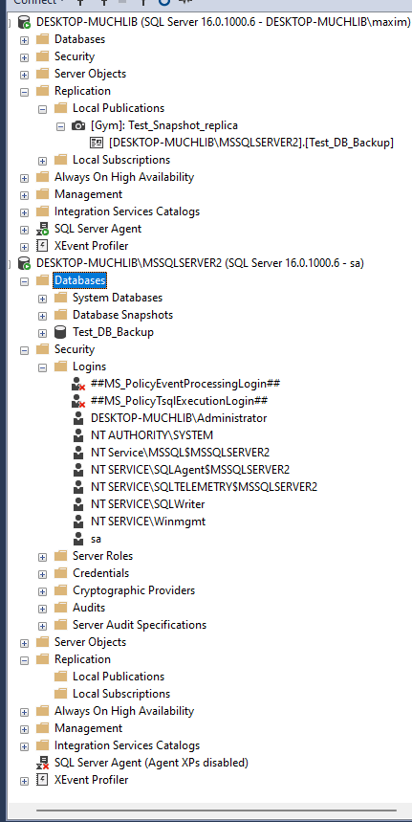
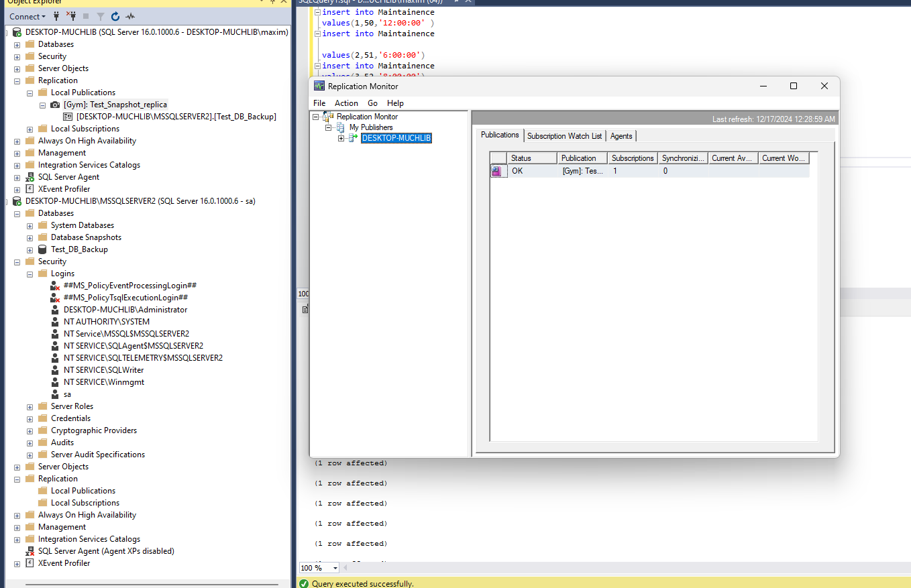

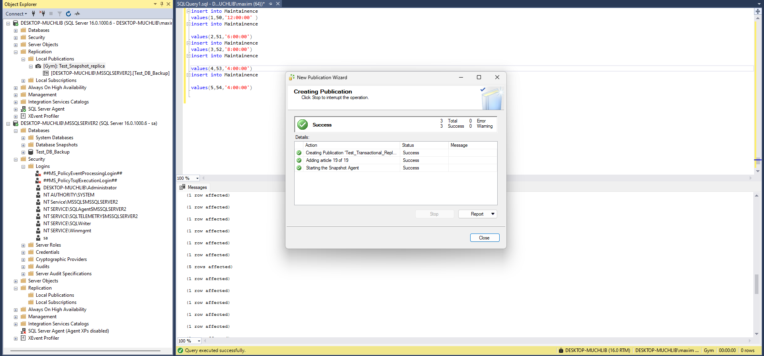
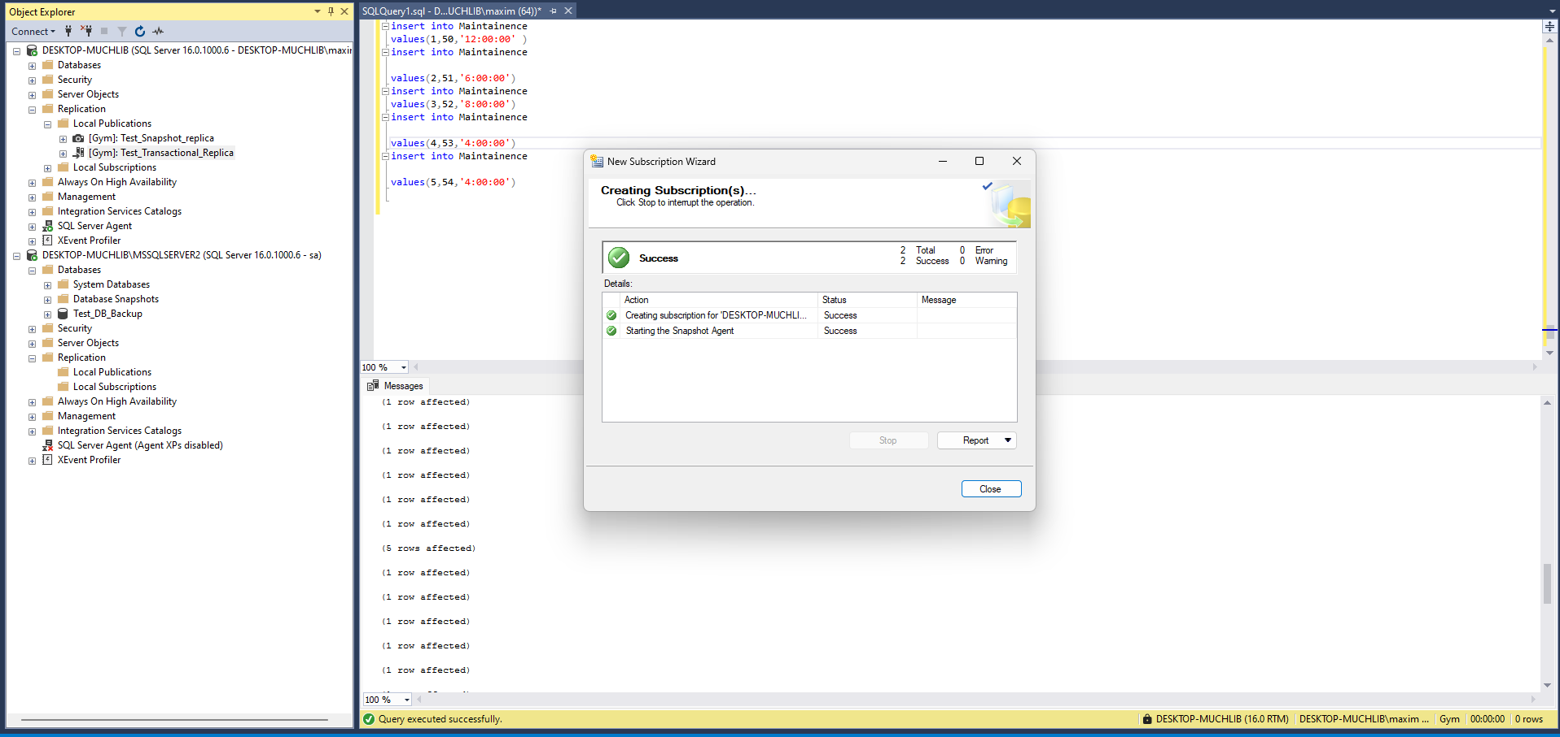
The final_replica(transactional/snapshot):
